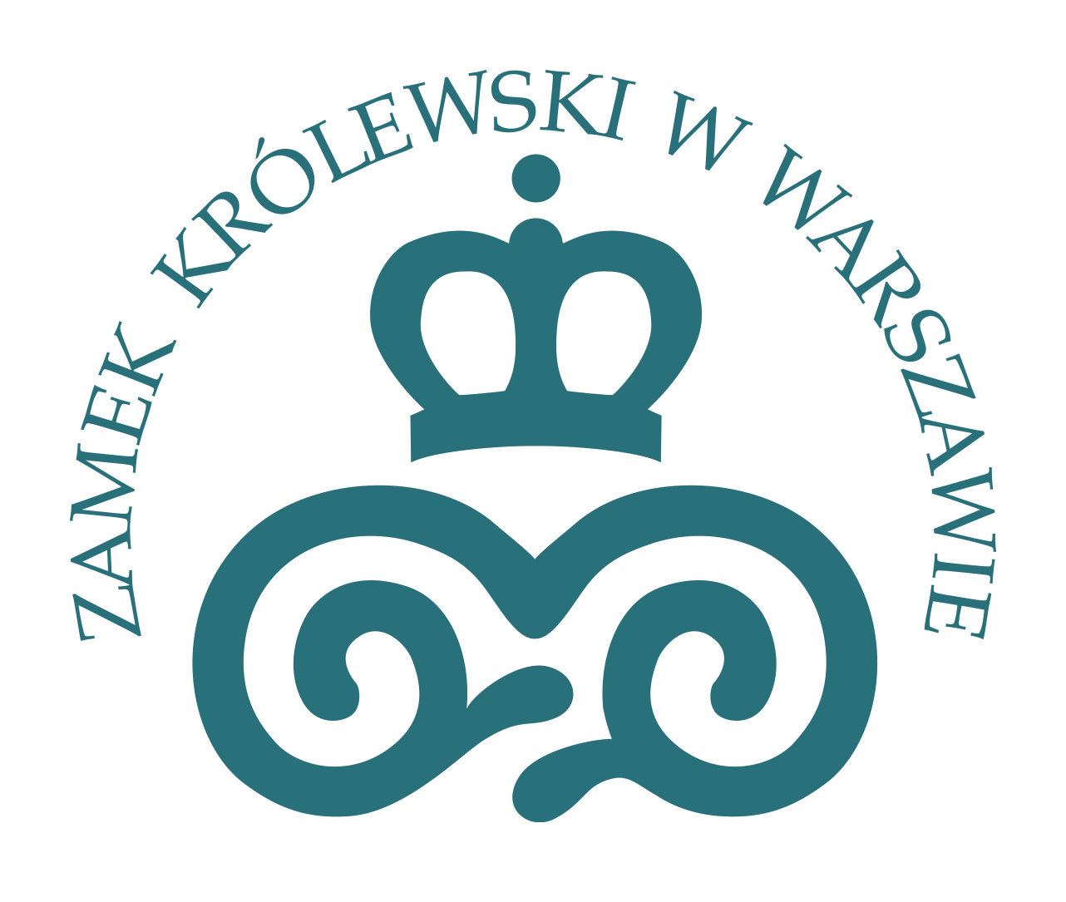

International conference

RITUALS OF POWER
The Ceremonies of Courts and States
from the Late Medieval Period to the Modern Era

PROGRAMME

The Kubicki Arcades in
The Royal Castle in Warsaw
6th-8th October 2016

DAY 1
Thursday, 6th October

8.30-9.30 Registration

9.30-11.00 Opening of the conference

Welcome address by the Director of the Royal Castle in Warsaw-Museum

Keynote lecture
Prof. Jeroen Duindam , Leiden University
Rituals and Royalty: a global perspective

11.00-11.30 Coffee & tea

11.30-12.45 PANEL 1
Ceremonial space of a royal court
Chair: Dr Lars Ljungström
Alexandra Nancy Johnson, University of Edinburgh
Mary Stuart’s Holyrood state apartments: performance of ceremonial ritual

Prof. José Eloy Hortal Muñoz, Universidad Rey Juan Carlos
Courtier ceremonies, Etiquette and courtly space at the Spanish Royal Sites of the 17th century: from Renaissance to Baroque

12.45-14.00 Lunch break

14.00-15.30 PANEL 2
Ceremonial interactions: urban and monarchical contexts
Chair: Prof. Wojciech Tygielski

Dr Samuel Morrison Gallacher, The Medici Archive Project, Florence
The Evolution of the feast of San Giovanni from Republican Ritual to Medici court ceremonial

Prof. Edmund Kizik, The Tadeusz Manteuffel Institute of History, Polish Academy of Sciences
Uncomfortable allies . Ceremonies in honour of Russia's rulers in Gdańsk, Elbląg and Toruń in 18th century

Prof. Susan P. McCaffray, Department of History University of North Carolina, Wilmington
Performing Urban Monarchy at the Winter Palace In Imperial St. Petersburg

15.30-16.00 Coffee & tea

16.00-18.00 PANEL 3
Rulers-subjects communication through ceremonial and ritual
Chair: Prof. Paweł Dobrowolski

Dr Gábor Kármán, Hungarian Academy of Sciences, Center for the Humanities, Institute of History
Not the Ruler, but the Land: Estates as Corporations in the Early Seventeenth-Century Ceremonial Order

Prof. Jolanta Choińska-Mika, Historical Institute, University of Warsaw
Senators’ speeches in Polish-Lithuanian Parliament under the Vasas – between communications and ritual

Dr Andrea Merlotti, Centro Studi della Reggia di Venaria, Torino
Oath and Hand-kissing: ceremonies of Kingship in a «Monarchia composita» (Sabaudian States from 17th to 19th centuries)

Dr Anne Byrne, Birkbeck, University of London
The paradox of the lit de justice: loving and defying the king in the eighteenth century

DAY 2
Friday, 7th October

8.30-9.00 Registration
9.00-11.00 PANEL 4
Female courts in ceremonial context
Chair: Prof. Jakub Basista

Prof. Vladimir Shishkin, Institute of History, Saint-Pétersburg State University
The daily court ceremonial of the French Queen in the 16th century

Dr Janet Dickinson, New York University in London
Approaching the Queen: chivalric culture and political power in the rituals of everyday life at the court of Elizabeth I

Prof. Silvia Mantini, Department of Human Sciences University of L'Aquila
Rituals of Power Embodied in a Woman: Margaret of Austria (1522-1586), Daughter of Charles V, and her Ceremonies between the Empire and the Farnese Court

Dr Katarzyna Kuras, Institute of History, Jagiellonian University, Krakow
Demonstration of prestige and influence. Participation of queen Maria Leszczyńska’s courtiers in court and state ceremonies.

11.00-11.30 Coffee & tea

11.30-13.00 PANEL 5
Legitimisation through ceremonies and rituals I
Chair: Dr Hieronim Grala

Dr Tiago Viúla de Faria, Instituto de Estudos Medievais, Universidade Nova de Lisboa
Politising Ceremonial in the Late Middle Ages: The Seating of Garter Knights in St George’s Chapel, Windsor

Prof. Juan Chiva Beltrán, IHA Research Group (Iconography and Art History) Universitat Jaume I, Castellón, Valencia
Legitimizing Philip II in the Portuguese Empire. The Oath ceremony at Goa (1580 – 1582)

Prof. Endre Sashalmi, Department of Medieval and Early Modern History, University of Pécs
Communicating Legitimacy by Distributing Coronation Coins: Case Studies in the Iconography of Power in the Eighteenth-Century England and Russia.

13.00-14.00 Lunch break

14.00-16.00 PANEL 6
Legitimisation through ceremonies and rituals II: Enthronement and coronation
Chair: Dr Philip Mansel

Dr Covadonga Valdaliso, Centro de História da Sociedade e da Cultura – Universidade de Coimbra/ Centro de História – Universidade de Lisboa
Transmitting the Ceremonies: Kings’ Coronations in the Late Middle Ages in Castilian and Portuguese Chronicles

Dr Dominik Szulc, The Tadeusz Manteuffel Institute of History, Polish Academy of Sciences
The election procedure and the enthronement ceremony of the joint Polish- Lithuanian rulers in light of the events of the years 1501-1506

Dr N. Zeynep Yelce, Sabanci University, Istanbul
Where Exactly is the Throne? Ottoman Enthronement Ceremonies in the Sixteenth Century

Prof. Pablo González Tornel, Department of History, Geography and Art, Universitat Jaume I
Four kings for Sicily. Proclamations and coronations in Palermo (1700-1735)

16.00-16.30 Coffee & tea

16.30-18.00 PANEL 7
Legitimisation through ceremonies and rituals III: dynastic dimention
Chair: Dr Samuel Morrison Gallacher

Prof. Inmaculada Rodríguez Moya, Universitat Jaume I
The Royal Baptism in the Spanish Court: art and ritual from the 15th to the 18th century.

Dr Mirosława Sobczyńska-Szczepańska, Institute of Art History, University of Silesia, Katowice
Marriage ceremonial at the courts of the later Jagiellons and Spanish Habsburgs

Prof. Géza Pálffy, Hungarian Academy of Sciences, Budapest
Funerals and Coronations: Dynastic Heraldic Representation in Central Europe
from the 15th to the 17th Century

DAY 3
Saturday, 8th October

9.00-10.30 PANEL 8
Visualising ceremony and ritual
Chair: Dr Fabian Persson

Jill Harrison, Open University
Sovereignty, Politics and Performance: Giotto’s Secular Allegories of Power and Diplomacy in Angevin Naples

Prof. Barbara Arciszewska, Institute of Art History, University of Warsaw
Operas and Masquerades: Court rituals and entertainments under George I of Brunswick-Luneburg (1660-1727) in electorate of Hanover and Britain

Prof. Andrey Kostin, Institute of Russian Literature, Russian Academy of Sciences, St. Petersburg
Emblems and Splendour, or What and How did Artificial Fire Communicate: shifts in symbolic nature of Russian fireworks in the 18th century

10.30-11.00 Coffee & tea

11.00-12.30. PANEL 9
Evolution of ceremonial practices: late 18th -20th centuries
Chair: Dr Anna Kalinowska

Dr Philip Mansel, The Society for Court Studies, London
From Time to Space: the Transformation of French Court Ceremonial from Louis XIV to Napoleon I

David San Narciso Martin, Complutense University of Madrid
Between dynastic parties and ceremonies of state. The reconfiguration of the ceremonial system in the twilight of the ancient regime Spain, (1814-1833)

Nicholas Dixon, Pembroke College, University of Cambridge
The Evolution of the British Coronation Rite, 1761-1953

13.00 Closing remarks

